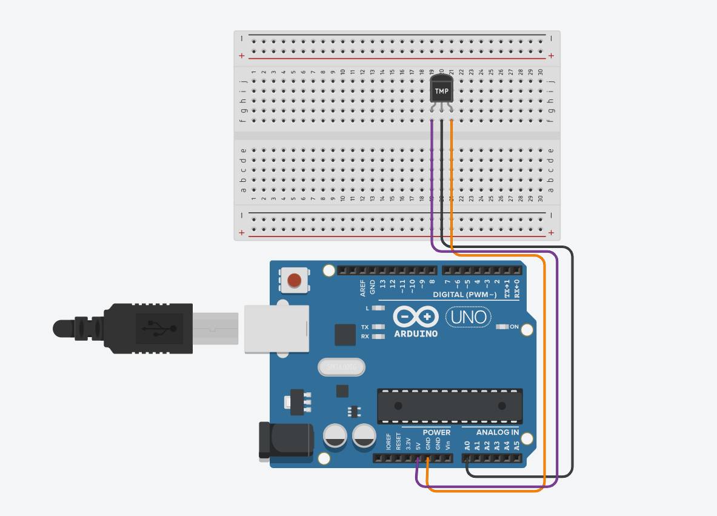

char degree = 176;
void setup ()
{
pinMode(A0,INPUT);
Serial.begin(9600);
}
void loop()
{
int temp = analogRead (A0);

float voltage = (temp*5)/1024;
float milivolt = voltage*1000;
float celsius = (milivolt- 500)/10;
float fahrenheit = (celsius*9/5) + 32;

Serial.print("10 bit number : ");
Serial.println(temp);

Serial.print ("voltage : ");
Serial.print(voltage);

Serial.print("milivolt : ");
Serial.print(milivolt);
Serial.print("V");

Serial.print("celsius : ");
Serial.print(celsius);
Serial.println(degree);

Serial.print("fahrenheit : ");
Serial.print(fahrenheit);

delay(1000);
}

